Covid-19 - Remote Consultations and IT

Remote Consultations
As primary care moves to a total triage system, NHSE have produced a document with advice on how to establish a remote "total triage" model in general practice using online consultations. This document works through the set up process including implementation within PCNs with resources for virtual eHubs. Appendix 1 also has practical guidance for reception staff managing the workflow. There is funded implementation support available to help with the roll out and effective use of these tools, so please do take advantage of this. Please contact your NHSE/I regional team or the NHSX Implementation Team to access this support. NHSE have also produced an Implementation Toolkit. There is also a wealth of guidance on the FutureNHS Platform for online consultations.
The King’s Fund was commissioned by the Department of Health and Social Care (summer 2020) to look into staff experiences of remote working in general practice. Using this work, and their previous research into effective teams, they've developed this short digital guide for practice and PCN leaders to help them adopt practices and techniques to ensure that their teams work as well as possible, even if all the members of the team can’t be physically together in one place.

Indemnity cover
One question that is frequently asked is " am I covered by the state indeminity" for online consultations. The Clinical Negligence Scheme for General Practice (CNSGP) covers all primary care services commissioned under a General Medical Services (GMS), Personal Medical Services (PMS) or Alternative Provider Medical Services (APMS) contract, where these services are provided directly or under a direct sub-contract.
CNSGP have provided a guideline document for general practice during Covid -19 and this states: -
Q. I am a GP who is working from home carrying out remote consultations via telephone and online systems. Do I have indemnity cover for this?
A. As long as you are providing primary medical services under one of the standard general practice contracts (GMS, PMS, APMS) for England, to a patient registered in England, then your location is not relevant for the purposes of indemnity cover.
By providing such a service, under such a contract, to such a patient, even if this is done remotely and via telephone and online systems, you are covered under the Clinical Negligence Scheme for General Practice (CNSGP).
However, we would remind you will need to maintain membership with your medical defence organisation (MDO) in respect of activities and services not covered by CNSGP, eg medico-legal matters outside claims.
Examinations perceived to be intimate
Another frequent question is around examinations that may be perceived to be intimate on a video consultation. There is a detailed chapter in the RCGP/NHSE document that looks at this topic. Considerations around consent, both implied and explicit, mental capacity, chaperones all need to be considered and documented. As a general rule, remote intimate examinations should not be video and audio recorded and patients discouraged from sending images of intimate parts of their body. Updated to this, new guidance published in July 2020, is specific to the key principles for intimate clinical assessments undertaken remotely. It is aimed at clinicians who are consulting remotely with patients through a digital channel (e.g. online, email, text, video-link) across healthcare settings in England.
The principles described in this guidance aim to support patients to access care in a way that meets their needs and to support clinicians to provide care in a way that is in the best interests of their patients, whilst protecting both from the risks associated with remote intimate assessments.
The production of this guidance has also lead to amendments of legal guidance from the Crown Prosecution Service on indecent and prohibited images of children..

Prescribing in Remote Consultations
GMC updated guidance (Feb 2021)
With more and more remote consultations the GPC thought it important to highlight that the GMC have published updated guidance on prescribing, to support doctors who are increasingly seeing patients via remote and virtual consultations.
Key updates include:
New advice for doctors not to prescribe controlled drugs unless they have access to patient records, except in emergencies.
Stronger advice on information sharing, making it clear that if a patient refuses consent to share information with other relevant health professionals it may be unsafe to prescribe.
Alignment with the GMC’s updated Decision making and consent guidance, highlighting the importance of good two-way dialogue between patients and doctors in all settings.

Resources
There are a wealth of resources around remote triage and we have listed below some we feel are particularly useful.
CQC GP mythbuster 100 - Online and video consultations and receiving, storing and handling intimate images
The Principles of Safe Video Consulting
The RCGP have published guidance in conjunction with NHSE&I on the principles of safe video consulting in general practice.
The RCGP have further published (Nov 2020) Remote versus face-to-face: which to use and when?
NHS England have developed a range of resources to help practices implement this approach, and The BMA also has some advice and guidance on remote consultations.
NHSE have published two visual resources to support primary care in delivering video consultations
Please click the images to access the resources.
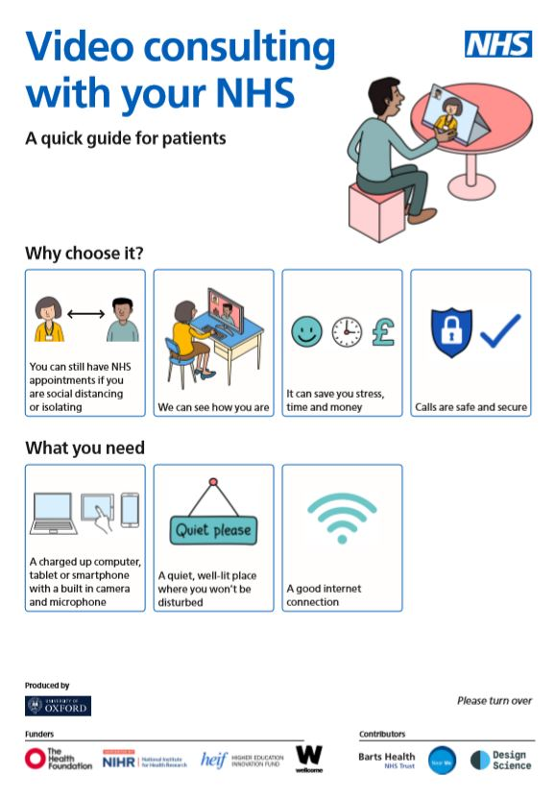

1. Video consulting with your NHS is a quick step-by-step guide for patients which explains the benefits of a video consultation and provides practical guidance on how to start, have and finish a video consultation.

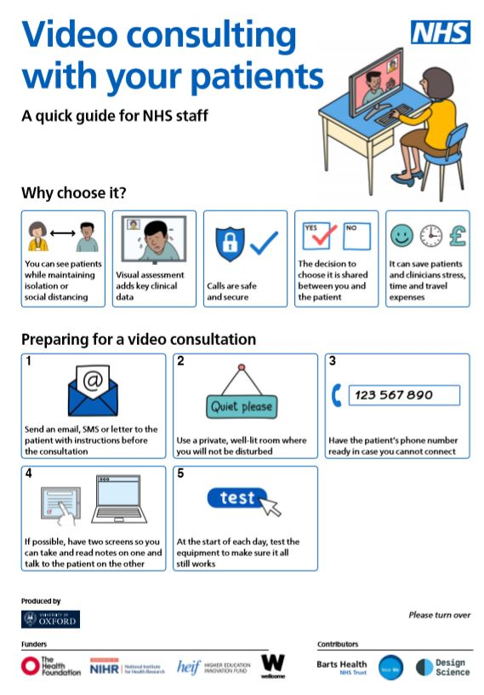

2. A similar quick step-by-step guide aimed at NHS staff is also available and covers practical tips on running a video consultation.

Trisha Greenhalgh, on behalf of the IRIHS research group at the University of Oxford has produced an excellent guide entitled Video consultations: a guide for practice . Within this are 4 handy one page guides to
- When is video appropriate?
- How can our practice get set up?
- How to do a high quality consultation
- A guide for patients on consulting by video
E-LfH have a session module on Remote Triage in General Practice, this may also be helpful for any returning GP's to use as part of a refresher programme.
Watch this video by Dr Camilla Janssen for tips and tools on "Remote Paediatric Consulting"
With thanks to eGP learning for their useful resource entitled Quick Telephone Consultations Tips for Primary Care.
FREE resources on telephone and video consultations
Take a look at our webpage for Electronic Prescribing Service (EPS) that also includes details for EPS in remote consultations.

Microsoft 365
An agreement has been struck between NHSX, NHS Digital and Microsoft to enable all eligible organisations in England to access Microsoft 365 digital tools.
It secures access to a variety of Microsoft applications, building on an agreement first announced in April 2018 that enabled NHS organisations to use Windows 10 to strengthen their defences against cyber attacks.
The NHS Digital press release says "GPs, consultants, nurses, therapists, paramedics and support staff, will have access to services within Microsoft 365, ensuring they are able to use tools such as Microsoft Teams, which will enable staff to collaborate more effectively through instant messaging, audio and video calls".

Remote working - laptops
Annex A of the Letter 3 update from NHSE (updates during Covid-19) sets out the Digital Primary Care assistance available. We are advised that local commissioners should provide the equipment and support services necessary to facilitate remote working/triaging. If local commissioners are unable to respond either through lack of equipment or funding or both, we are advised that they will be supported nationally. Please note that any equipment used for access to clinical systems must conform with Securing Excellence in Primary Care: The Primary Care (GP) Digital Services Operating Model 2020-21 standards .

It is also important to keep in touch with all of the practice team and Microsoft Teams is an excellent resource for this (and used by your very own LMC!) NHSmail has been enabled to work with this programme and guidance on this is available here .

Smartcards
If problems are not sorted locally, please contact pcdt@nhsx.nhs.uk .

SMS messaging
At this time, practices will need to be able to send messages to patients in much greater volume than normal. Most areas already have unlimited SMS plans. For those that don’t and need additional credits for SMS messaging, they should urgently secure the additional capacity through their local commissioning groups. If your CCG needs additional funding to cover this, please ask that they contact pcdt@nhsx.nhs.uk.
NHSX can be contacted for any queries around IT and Covid-19 at digitalprimarycareengland@nhsx.nhs.net

